# Alarm System

## Introduction

The alarm system provides clear and unambiguous representation of all the alarms that take place at a certain time and present that on any screen that has the rights to show that alarm. There is a difference between the alarm system and the Duty alarm system. The alarm system shows all the alarms to all the stations with the specific rights. The Duty alarm system divides the (machinery) alarms to a station “on duty” in case of an unmanned machinery space.

## Alarm handling

Alarm handling is determined in a set of international rules by standardization organisations. These rules are visualized in Figure 2‑1.

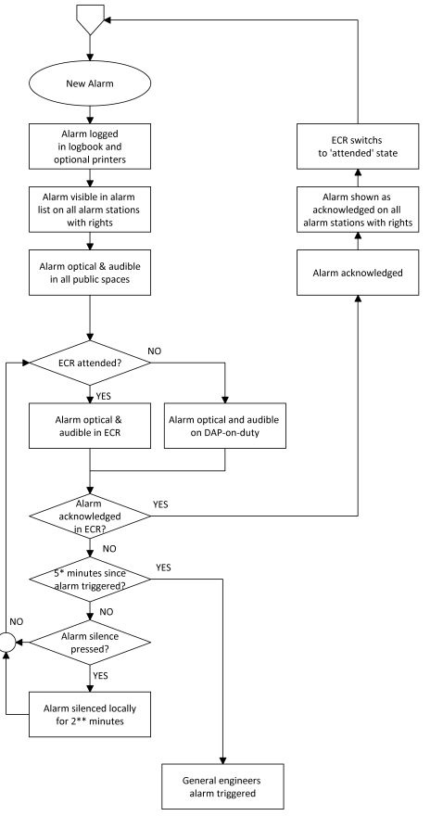

Figure 2‑1: typical alarm sequence

## Alarm handling in the alarm mimic

As shown in Figure 1‑25, all cautions, warnings and critical alarms will be shown in the taskbar and, more extensively, in the main window of the Alarm mimic. In *Table 5: Alarm Icons,* you will find the explanation of the various alarm icons and their meaning.

When you look further at the alarm mimic, you’ll notice more values and buttons. The row just above the alarm window (see Figure 2‑2), is the *alarm group row*. Depending on the alarm groups set here at initialisation of the system, you can see in which groups the alarms on the alarm page reside.



Figure 2‑2: Alarm group row

When even a single alarm within a group is active, the group label will turn red. This way you can see quickly in which group there are alarms.

When you click on this specific group label, the alarm mimic will be filtered to show only the specific alarms in that group. This will come in handy when you have a lot of alarms on the screen. After 10 seconds it will revert to the complete alarm list.

When you want to silence or acknowledge an alarm, you can double click on the alarm entry. Depending on the rights your station has, double-clicking will either silence, acknowledge or do nothing with the entry. Alternatively, you can click the silence/acknowledge-button (see Figure 2‑3) to silence/acknowledge all visible alarms in the alarm mimic. Depending on how many alarms you have, you will need to click one or more times to do this for all the alarms as this action only applies to the alarms currently visible on the screen.



Figure 2‑3: silence/acknowledge-button

### Explanation of alarm rights

During commissioning of the system, all stations will be set to their respective alarm station names with the distinctive rights set accordingly. Class demands that the only place where an alarm may be acknowledged is the space where you can act upon the alarm directly. This usually means that 99 percent of the alarms can only be acknowledged in either the engine room (ER) or the engine control room (ECR). For the other stations, the rules state that the alarms (if shown) can only be silenced. This means that the alarm stays unrectified and unacknowledged and only the buzzer will be silenced (at most for 3 minutes).



*If you are unable to acknowledge or silence alarms, you probably don’t have the rights.*

## Duty alarm system

The *Duty Alarm System* provides (machinery) alarms to bridge, cabins and public areas for an unattended (unmanned) machinery space. The duty alarm system is configured upfront.

*Duty Alarm Panels* (DAP’s, see Figure 2‑5) at specific locations are connected with the automation system via the LAN-network. They display the information for machinery alarms and settings such as alarm group status, operation status, and on-duty selection.

The duty alarm system provides for signaling of Engine Control Room (ECR) to the cabins and bridge by a *Duty Alarm Panel* (DAP) or on a *Local Operator Panel* (LOP).

An engineer on duty can be selected from the *Operator Workstation* (OWS). He will be warned when an critical alarm is present in the unmanned engine room.

An engineer can be called on duty from the ECR on the OWS. Each station has its own caller identification.

When no DAP is used, the duty alarm system can be implemented with small or larger hardware panels as shown in the following figures:

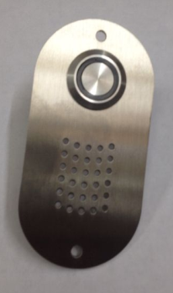 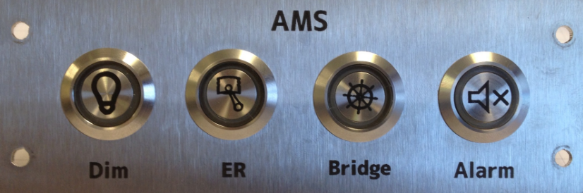

Figure 2‑4: typical Alarm panels

These panels come in the following editions, with their own respective operation.

|  |  |
| --- | --- |
| Panel horizontal-vertical | |
|  | |
|  | |
| Location of use: | Crew cabins that can be selected for Bridge duty as well as for ER duty |

|  |  |
| --- | --- |
| Panel horizontal-vertical | |
|  | |
|  | |
| Location of use: | Crew cabins that can be selected for ER duty |

|  |  |
| --- | --- |
| Panel horizontal-vertical | |
|  | |
|  | |
| Location of use: | Crew cabins that can be selected for bridge duty |

|  |  |
| --- | --- |
| Panel horizontal-vertical | |
|  | |
|  | |
| Location of use: | At each entrance door of the ER, or in the ECR |

|  |  |
| --- | --- |
| Panel horizontal-vertical | |
|  | |
|  | |
| Location of use: | Main or secondary bridge |

|  |  |
| --- | --- |
| Panel horizontal-vertical | |
|  | |
|  | |
| Location of use: | All spaces where Bridge duty crew can be available (no duty select) |

|  |  |
| --- | --- |
| **Button** | **Explanation** |
|  | Dim the button LED’s of that panel  Illuminates when panel is active |
|  | Silence the alarm  Illuminates when an alarm is active |
|  | No push activity  Illuminates when ER duty |
|  | No push activity  Illuminates when Bridge duty |
|  | Press for attended/unattended mode  Illuminates when attended |
|  | No push activity  Illuminates when timer is active |

Table 6: Alarm panel buttons

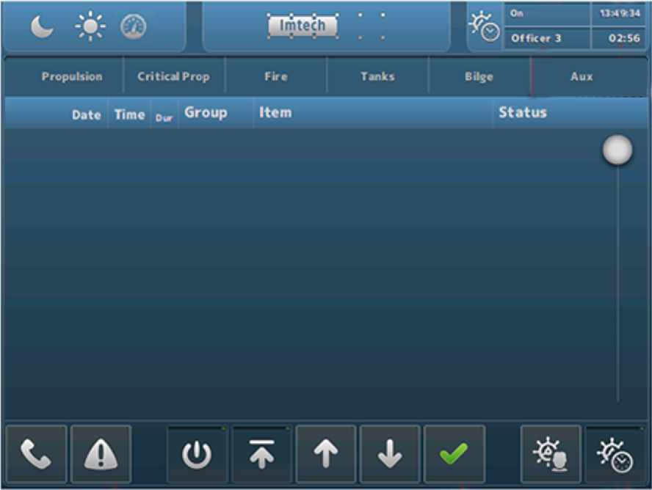

Figure 2‑5: Typical DAP screen

### Extra buttons alarm mimic

Depending if the station is set as a specific alarm station, some extra buttons will appear at the bottom of the alarm mimic. When the OWS is set-up as a bridge station, the icons as shown in Figure 2‑6 will appear. When the OWS is set-up as an ER station, the icons as shown in Figure 2‑7 will appear.



Figure 2‑6: Bridge set-up icons



Figure 2‑7: ER set-up icons

The meaning and handling of these icons are explained in the following table.

|  |  |
| --- | --- |
| **Button** | **Explanation** |
|  | Press to print (part of) the alarm list |
|  | Press and select space or crewmember to call |
|  | Switch station On/Off (when applicable) |
|  | Scroll to top |
|  | Scroll up |
|  | Scroll down |
|  | Acknowledge or silence alarms |
|  | Select crew for Bridge duty |
|  | Switch BNWAS On/Off |
|  | Select crew for ER duty |
|  | Switch personnel alarm On/Off |

Table 7: Alarm mimic set-up icons

The *Call* and *Duty Select* buttons have some additional choices, depending on who you can call or who you can select for duty. This will be configured upfront and will look as in Figure 2‑8 and Figure 2‑9. First select the *Call* or *Duty Select* button and then choose from the following menu.

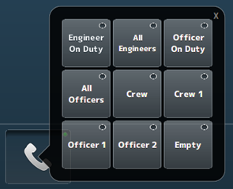

Figure 2‑8: Call function

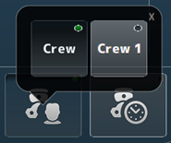

Figure 2‑9: Duty select function

Additionally, you can see the station that is calling you on the main screen (while hearing a buzzer tone if available). You can click on the message to make it disappear (see Figure 2‑10).

The person that is on duty will be visible on all stations in the right upper corner of the screen.



Figure 2‑10: receiving call message

Finally in the upper right corner of the alarm mimic some crew and time information will be shown (see Figure 2‑11). Here you can see if the ER is attended or unattended, who is on duty, the time and the timer (remaining time) from either the ER Personnel alarm or the BNWAS alarm.

The left button is the reset button for the timer. The right button is the same as the button *Switch station On/Off*.



Figure 2‑11: Crew information

### Duty alarm principal

The duty alarm system is used for the transfer of alarms to the technical crew in case of an unattended machinery space. The duty alarm system will be configured from a particular OWS. The duty alarm system provides unambiguous audio visual annunciation of alarms and warnings via a dedicated banner located at the top of the alarm panel screen.

A watch and call system extends the central alarm system to engineers' cabins and public areas when machinery spaces/control rooms are unattended.

### Alarm types

#### Alarm detection for analogue signals

The following functions are included:

* Instrument failure alarms
* Low-low process alarms with or without action (slow-down)
* Low process alarms
* High process alarms
* High-high process alarms with or without action (slow-down)
* Return to normal detection with dead-band to avoid alarm fluctuations
* Adjustable filter factors to filter fluctuations in the incoming signals
* Time delay of alarm triggering and return to normal messages.

#### Alarm detection for on/off (two state) signals

The following functions are included:

* High process alarms
* Return to normal detection
* Time delay of alarm triggering and return to normal messages.

#### Alarm detection for on/off signals with line check

The following functions are included:

* High process alarms (open or closed)
* Line broken alarm
* Line short alarm
* Return to normal detection
* Time delay of alarm triggering and return to normal messages.

### Attended alarm mode

NavVision will transfer the alarm to the activated location.

In case of an attended or manned machinery space this location will be the:

* Engine Control Room (ECR)
* Accommodations (e.g. mess room and public areas).

### Unattended alarm mode

In case the machinery space is left “unmanned”, alarms that will come in will be redirected immediately to the selected Duty Alarm Panel.

The “Unattended” mode can be activated on the workstation in de ER or the ECR.

NavVision will direct the alarm to the activated location.

In case of an unattended or unmanned machinery space this will be:

* The engineer on-duty
* Engine Control Room (ECR)
* Accommodations (e.g. mess room and public areas).

New alarms are indicated respectively on the DAP of the engineer on duty in the ER and in public spaces such as the mess room. On the panels, the alarm sounding (horn/buzzer) can be silenced (only local), but the alarms still need to be acknowledged on the OWS within the relevant technical area.

If alarms are not acknowledged within a specific period of time, the *General Engineers Alarm* (GEA) is invoked, independent from the *Attended/Unattended* mode. Once the GEA goes off, the alarm will sound on all alarm stations

## 

### How to acknowledge an alarm

The alarms must be acknowledged on the OWS in the Engine (Control) Room by means of:

* Double clicking the corresponding alarm line (alarm viewer)
* Click the Silence/Acknowledge button

### How to silence an alarm (not at ECR)

You can silence an alarm on all other locations (except GEA and Fire alarms).

This will silence the local alarm buzzer for 3 minutes, but will not acknowledge the alarm.

The engineer is required to go to the Engine (Control) Room to acknowledge the alarm.

### When will an alarm disappear

An alarm will disappear only when rectified AND acknowledged. Acknowledged alarms will show in the normal instrument colour.